Customer Name: | John Doe
Address: | Eveque Leisure Equiment Ltd  Wincham Ave  Wincham  Northwich  United Kingdom  CW9 6GB
Phone 1: | 01234 567 891
Phone 2:
Order Date: | 03 March 2021
A
B
D

R

S
C
E
E
Shape: | Square or rectangle corner radius
Spa Manufacturer: | Please specify
Model & Year: | Please specify |  | C
Dimensions: | A: 2440 mm
 | B: 2440 mm
Corner Radius: | R: 220 mm
Skirt Length: | S: 130mm
Strap Length: | C: Please specify  E.g. Total length = 250mm (120mm below skirt) + clip.
Strap Qty: | 4
Strap Position  Parallel to hinge  Corners  X | D:  E:  Please specify position + length  E.g. 2 each parallel to hinge, centered 1300mm apart.
Colour: | Dark Brown /Tan/Charcoal Grey/Dark Grey/Leather Textured Black  (Please select colour required)
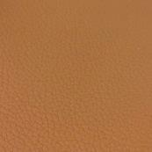  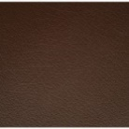 | 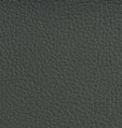  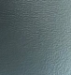  
5-3” Drop  Encapsulated core |  | Eveque Order No:  Eveque Proforma No:

